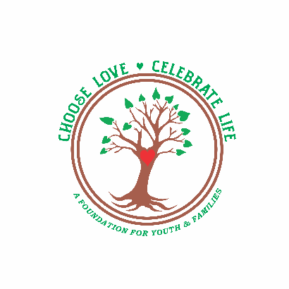
Choose love. Celebrate life.
This Photo by Unknown Author is licensed under CC BY-SA
A Foundation for Youth and Families, Incorporated
♥ PO Box 601 Toms River, NJ 08754 ♥ https://www.CLCLFoundation.org ♥ 848-227-1205 ♥ tdesousa@clclfoundation.org ♥ EIN: 99-0461801

CLCL Foundation Donation Form
Cash or Check donations - please complete this form in its entirety and return it at your earliest convenience:
CLCL Foundation
PO Box 601
Toms River, NJ 08754
Please make checks payable to “CLCL Foundation,” a 501(c)(3) public charity incorporated on December 30, 2023.

Name: _______________________________________________________________________________
____ Yes, I would like my name included on the CLCL Foundation website’s published Business Checking Register, so I can see when and how my donation was used.
____ No, my donation is Anonymous, and I do not want my name included on the Business Checking Register.
Please add the following 5 number/letter sequence at the end of Anonymous, so I can still track my donation on the Business Checking Register (example: Anonymous 2024F): _________________________________
Mailing Address: _______________________________________________________________________
____ Yes, please send me news, updates, fundraisers, and promotions.
____ No, please do not contact me.
Email Address: _________________________________________________________________________
____ Yes, please send me news, updates, fundraisers, or promotions.
____ No, please do not contact me.

Donation Amount: Every dollar helps us to reach our goal to restore you access to emergency sheltering services and expanded preventative care for youth and families. Thank you for helping Choose love. Celebrate life. A Foundation for Youth and Families, Incorporated.

____ $10 ____ $20 ____ $30 ____ $40 ____ $50 ____ $75 ____ $100

____ $150 ____ $200 ____ $250 ____ $300 ____ $400 ____ $ 500 ____ $1000

____ Other (please specify) ______________________________

